AMEX – EVENT SCHEDULING
2024 03 06

Attendees:
- Global Technology:
  - Kristen Baum: Sr. Product Manager
    - Product Manager for the UXP project, leading the meeting
  - Luis Bustos: Director, Technology Architect & Strategy
    - Data Architect for the UXP project, explaining the features and integrations
- Amex Team:
  - Jennifer Lemieux: Director Experiential Prod
    - From the BL side, involved in the project.
  - Grace Sullivan: Manager Business Leadership
    - Involved in the project to unify the data for the events, and they work on festivals for the BL side.
  - Jillian Tapper: Director Business Leadership
    - From the BL side, overseeing the golf and tennis portfolio for Amex.
  - Brian Baskett: SVP Director Experiential Prod
    - From the XB side, involved in the project.

Next steps
- Jillian provided the names of the following people to contact:
  - Jacob, the VP of theatre and B to B
  - Lindsay Wright, another VP of Amex
  - Caitlin, who gets event requests from Amex at a high level

Notes
- Planning:
  - The team can predict dates for annual events like golf, tennis, and Coachella festivals.
    - Allows for advanced planning, focusing on logistics rather than determining event dates.
    - Planning
      - Less about informing Experience Partners (XP) of event occurrences
      - More about initiating the planning with specific dates, especially for recurring events.
AMEX Account Teams
  - Teams
    - GABM (Global Advertising and Brand Management)
      - Same KPIs and measurement across the team.
      - Includes:
        - Team Golf

        - Team Tennis
        - Team Festivals
        - Team Sports
          - Has some tentpole projects and some that vary in scope and location
    - B2B & Theatre
      - Report to the same VP
      - Different metrics and clients
      - Some short notice events.
      - Includes:
        - B2B (Business to Business)
        - Team Theatre
    - Ad hoc
      - Other smaller projects, such as All the More Machine and Shop Small, which come up with a month's or a week's notice.
  - More challenging teams:
    - Team Sports
    - B2B
Metrics and KPIs
  - The metrics across the different teams vary depending on the department and the client. According to the transcript, some of the differences are:
    - GABM (golf, tennis, festivals, and sports) have the same KPIs and measurement around card member engagement, prospect information, and transactions and charge volume.
    - Theatre and B2B have different metrics and clients, and sometimes they have short notice events.
  - Reporting:
    - Wasserman does the main reporting for GABM, and Momentum provides the metrics to them on a sell sheet.
    - Other departments may not have a Wasserman or an IAT, and they may do their reporting differently.
  - Projects Jillian oversees:
    - Golf
    - Tennis
    - Festivals
    - One-off projects
      - Amex travel
      - Dining experience
      - Others

AMEX proprietary tool (LET)
  - LETT (Live Event Tracking Tool)
    - System that Amex uses to collect metrics such as card member engagement, prospect information, transactions, and charge volume at their events.
    - AMEX teams use LETT across all of their events and that they get the numbers from Amex and put them into a Google doc.
- Data collection and reporting process:
  - The process explained by Jillian is:
    - Oversee the golf and tennis portfolio for Amex, as well as festivals and some one-off projects.
    - Use LETT to collect metrics such as card member engagement, prospect information, transactions, and charge volume at their events.
    - Get numbers from Amex and momentum puts them into a Google doc for comparison and analysis.
    - All data is passed to Wasserman, which is another agency that does the main reporting for Amex.
  - Other work
    - The others work differently depending on the department and the type of event.
      - Theatre and B to B have different day-to-day clients and different KPIs than golf, tennis, festivals, and sports.
        - Some events are planned yearly, while others are one-off projects that come up with short notice.
        - Some events use LET to collect metrics
        - Others events use clickers, surveys, or inventory counts.
          - Surveys—wasserman owned, momentum does not get access too
        - Photo Ops, BA clickers (door counts, engagement counts,) all go to momentum BLs who enter it into a google sheetBA
        - Splash pages—would gather metrics from Splash and put into spreadsheet
        - QR Codes are client owned and not managed by Momentum

  - No use of the Data/Analytics team

Data Process:
  - Working with XP partners and Amex clients, and collecting metrics
  - Amex sends a brief to BL with the event details and objectives
  - BL works with XP to plan the dates, venues, budget, and staffing for the event
  - XP executes the event and collects metrics from various sources, such as LET, clickers, and inventory
  - BL gathers the metrics from XP and puts them into a Google Doc
  - BL sends the metrics to Wasserman, who does the main reporting for Amex
    - The metrics include card member engagement, prospect information, transactions, charge volume, and other KPIs
    - The metrics vary depending on the type of event and the client's needs
    - Golf, tennis, festivals, and sports have similar metrics and KPIs
    - Theatre and B to B have different metrics and clients
    - BL mentioned needed to “check wassermans work” ie. Check the data and numbers they report out against our google sheet
  - Some data is qualitive—like “overheard quotes” from people on site—this is collected by BAs or BLs in a casual way, and added to google doc
  - MISC giveaways: a number that XP would have, also goes into google doc
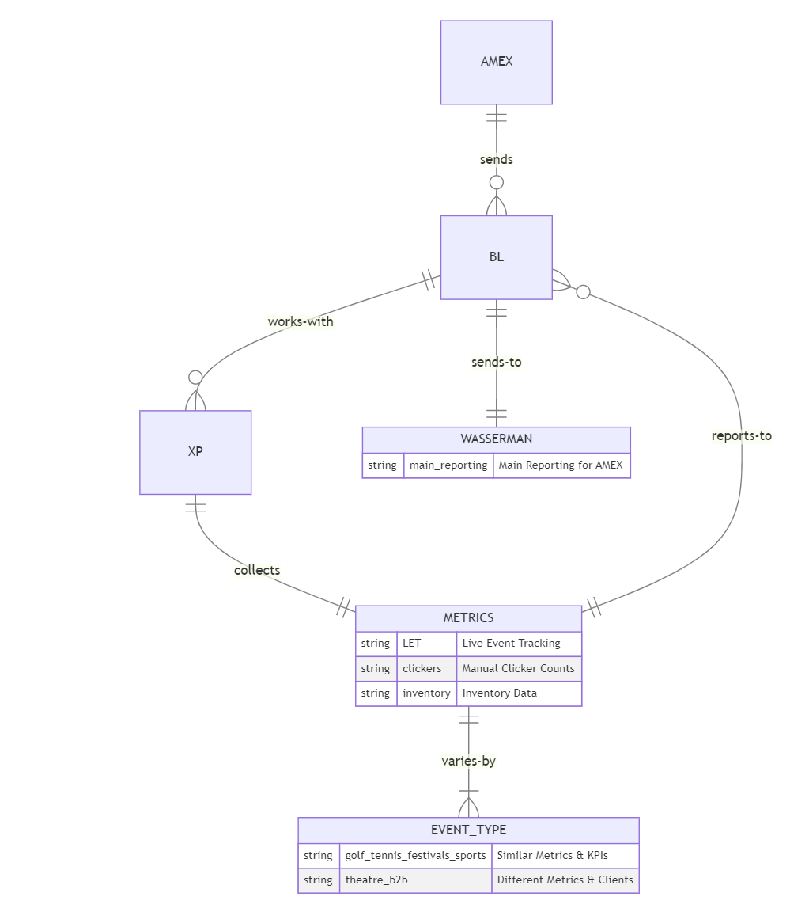
  - Some one-off projects that have different requirements and timelines

Vendors
Amex team uses different agencies for staffing their events
  - Event Staffing
  - USB9
  - Hype
  - These agencies provide:
    - Brand ambassadors
    - Important to note the BLs are in charge of BAs
    - Managers
    - Other staff who help with the on-site activations
      - Checking in card members
      - Giving out benefits
      - Collecting clicker data
The staff also have access to the Google Doc where they enter the data every night.

Functionality Wishlist:
  - Jillian Tapper:
    - A More Sophisticated Way of Collecting Data
      - A more advanced data collection method
        - Can provide insights and year-over-year comparisons, highlighting the limitations of the current Google Tracker method​​.
    - Historical Data Access
      - Wants access to historical data for a better analysis and understanding of trends over the years​​.
    - Predictability of Events
      - Mentioned the ability to predict dates for annual events like golf, tennis, and Coachella festivals, which aids in advance planning​​.
    - One-off Event Requests
      - Mentioned that requests for one-off events usually come from a high level within Amex, indicating a need for flexibility and quick response capabilities in planning and execution​​.
  - Jennifer Lemieux:
    - Clarity and Communication
      - Better communication from BL and Amex about event requests, dates, and budgets to minimize uncertainty.
    - Variability and Scope Management
      - A desire for less variability in project scope and a clearer understanding of project requirements ahead of time.
    - Advance Notice for Projects
      - Preference for more lead time on projects to allow for better planning and resource allocation.
    - Staffing and Resource Management
      - Indicated by the management of brand ambassadors and field staff, suggesting a desire for efficient staffing management possibly handled by BL rather than XP to streamline operations​​.
  - Wishlist recap:
    - Enhanced data handling
    - Analytical capabilities
    - Clearer communication channels
    - Improved operational efficiency in event planning and execution

Requirements table:

Overarching Theme | Category | Item | Requester | MVP | v1+ | Not in scope | Complexity
Data Collection | Data Management | More sophisticated data collection method | Jillian Tapper |  | ✓ |  | High
 | Data Access | Access to historical data | Jillian Tapper | ✓ |  |  | Medium
Event Planning | Predictability | Ability to predict dates for annual events | Jillian Tapper |  | ✓ |  | Low
 | Flexibility | Quick response for one-off event requests | Jillian Tapper | ✓ |  |  | Medium
Communication | Clarity | Clear communication on event details | Jennifer Lemieux | ✓ |  |  | Low
Project Management | Scope Management | Less variability in project scope | Jennifer Lemieux |  |  | ✓ | Medium
 | Planning | More lead time for projects | Jennifer Lemieux |  |  | ✓ | Low
Operational Efficiency | Staffing Management | Efficient staffing management | Jennifer Lemieux | ✓ |  |  | Medium

